Wavy Curvilinear Shapes
# Source: AI Source: Provided by: [Data Path: Persons Table -> ID Column: 1, Name_En Column: Motasem Essam] -> From: [ChatGPT] on [7/25/2026]
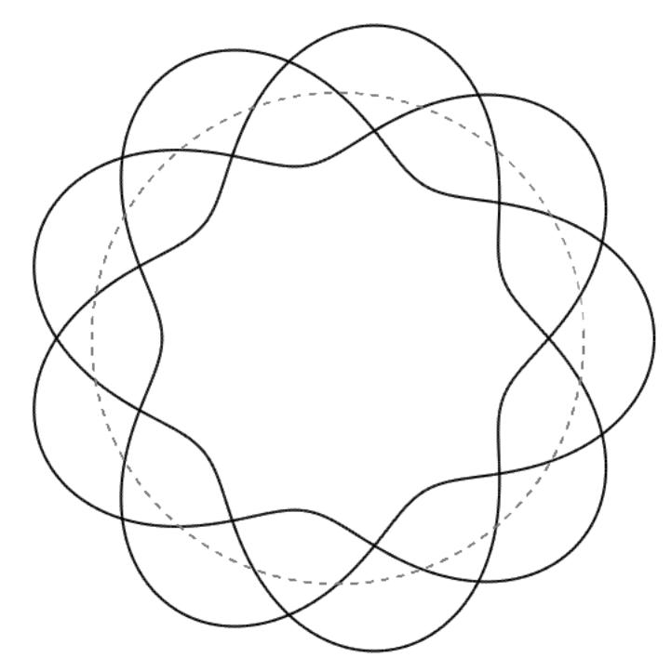
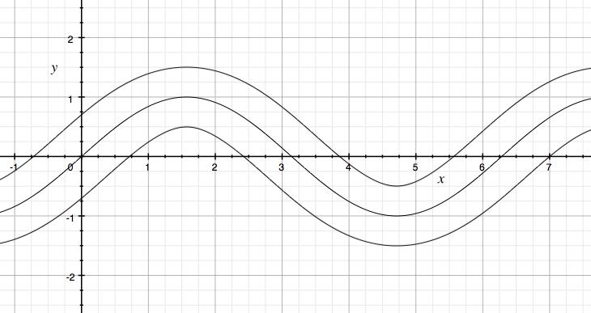
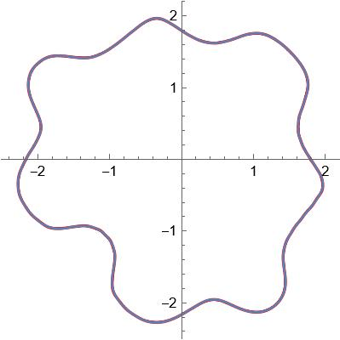
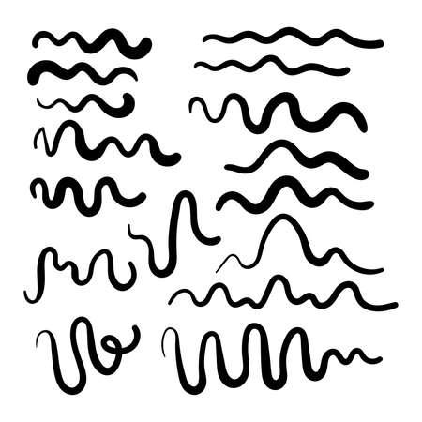
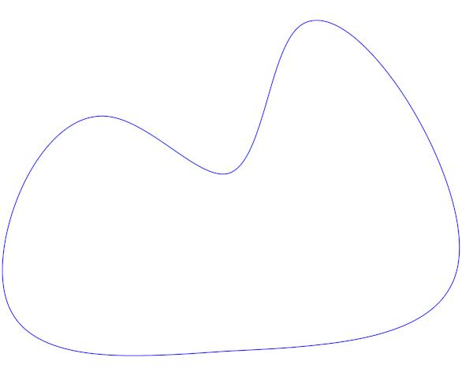

Definition
# Source: AI Source: Provided by: [Data Path: Persons Table -> ID Column: 1, Name_En Column: Motasem Essam] -> From: [ChatGPT] on [7/25/2026]
Wavy Curvilinear Shapes are curvilinear shapes whose boundaries or paths have a wave-like pattern, characterized by repeated or smoothly varying changes in direction.
A wavy shape may consist of smooth curves that repeatedly rise and fall, bend inward and outward, or alternate between different directions.
Wavy shapes can be:
- open or closed
- regular or irregular
- symmetric or asymmetric
- smooth or piecewise smooth
- simple or composite
The term wavy describes the visual or structural pattern of the curve rather than a single strict mathematical shape.

Fundamental Concept
# Source: AI Source: Provided by: [Data Path: Persons Table -> ID Column: 1, Name_En Column: Motasem Essam] -> From: [ChatGPT] on [7/25/2026]
The fundamental feature of a wavy curvilinear shape is undulation: the curve repeatedly changes its direction in a wave-like manner.
A simple mathematical model is a sinusoidal function:
$$y=Asin⁡\left(Bx+C\right)+D$$
where:
- A = amplitude
- B = frequency factor
- C = phase shift
- D = vertical displacement
The wavelength is:
$$\boxed{λ=\frac{2π}{∣B∣}}$$
and the amplitude is:
$$\boxed{∣A∣}$$
This is only one model of a wavy curve; many wavy shapes are not sinusoidal.

Main Characteristics
# Source: AI Source: Provided by: [Data Path: Persons Table -> ID Column: 1, Name_En Column: Motasem Essam] -> From: [ChatGPT] on [7/25/2026]
Wavy curvilinear shapes generally have:
- curved boundaries or paths
- repeated or varying undulations
- continuously or gradually changing directions
- peaks and troughs in many common forms
- variable curvature
- potentially periodic patterns
- potentially non-periodic patterns
- open or closed boundaries
- possible symmetry or asymmetry
The term wavy does not necessarily mean periodic.
A curve can be wavy without repeating exactly.

Types of Wavy Curvilinear Shapes
# Source: AI Source: Provided by: [Data Path: Persons Table -> ID Column: 1, Name_En Column: Motasem Essam] -> From: [ChatGPT] on [7/25/2026]
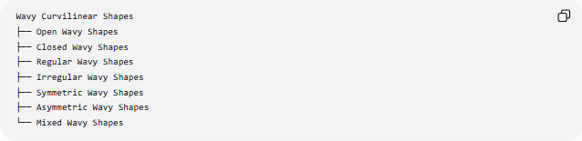
Wavy Curvilinear Shapes
├── Open Wavy Shapes
├── Closed Wavy Shapes
├── Regular Wavy Shapes
├── Irregular Wavy Shapes
├── Symmetric Wavy Shapes
├── Asymmetric Wavy Shapes
└── Mixed Wavy Shapes
These are primarily descriptive classifications, rather than a universally standardized mathematical taxonomy.

Open Wavy Shapes
# Source: AI Source: Provided by: [Data Path: Persons Table -> ID Column: 1, Name_En Column: Motasem Essam] -> From: [ChatGPT] on [7/25/2026]
An Open Wavy Shape is a wavy curve or path with distinct endpoints.
For a parametric curve:
$$r\left(t\right)=\left(x , \left(t\right)y\left(t\right)\right)$$
an open curve generally satisfies:
$$r\left(a\right)≠r\left(b\right)$$
Example:
●────╮ ╭────╮
╰────╯ ╰────●
It does not enclose a region by itself.
Examples
- open sine-wave path
- decorative wave
- undulating curve
- wavy freeform path

Closed Wavy Shapes
# Source: AI Source: Provided by: [Data Path: Persons Table -> ID Column: 1, Name_En Column: Motasem Essam] -> From: [ChatGPT] on [7/25/2026]
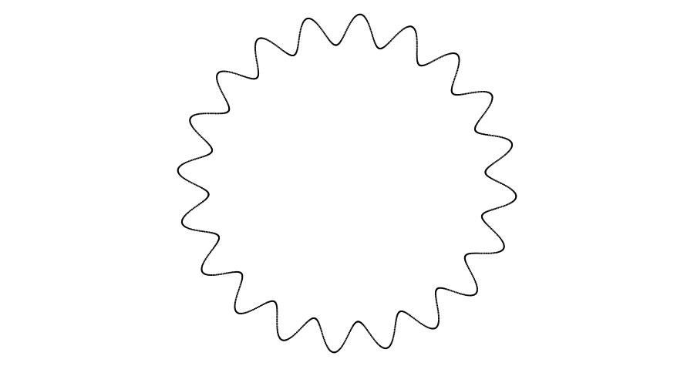
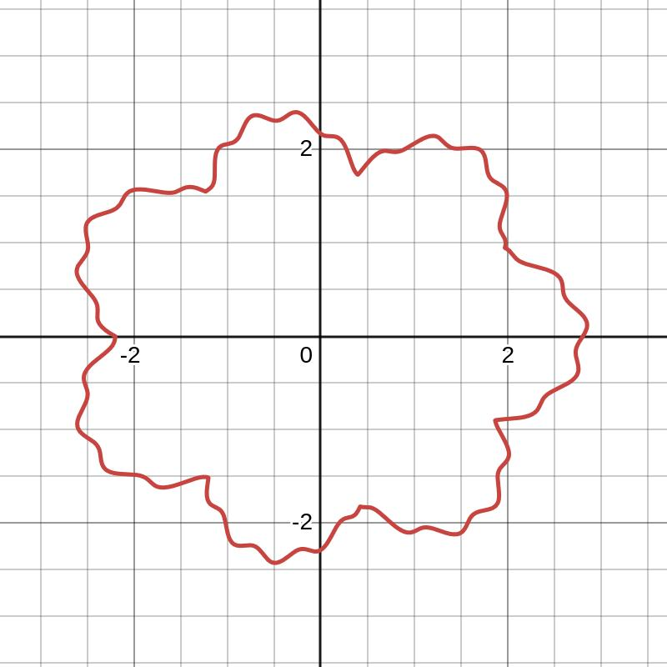
A Closed Wavy Shape is formed by a continuous wavy curve that returns to its starting point.
For a parametric curve:
$$\boxed{r\left(a\right)=r\left(b\right)}$$
A simple closed wavy curve encloses a region.
For example, a periodically varying radial curve can be written as:
$$r\left(θ\right)=R+Asin⁡\left(nθ\right)$$
where:
- R = base radius
- A = wave amplitude
- n = number of repeating undulations
Such a curve can produce a closed, wave-like boundary.

Regular Wavy Shapes
# Source: AI Source: Provided by: [Data Path: Persons Table -> ID Column: 1, Name_En Column: Motasem Essam] -> From: [ChatGPT] on [7/25/2026]
A Regular Wavy Shape has a consistent or repeating wave pattern.
Its undulations may have:
- equal or repeating amplitudes
- equal or repeating wavelengths
- consistent curvature patterns
- regular spacing
- repeated peaks and troughs
A simple example is:
$$y=Asin⁡\left(Bx\right)$$
where the wave repeats periodically.
Important note
Regular wavy shape is a descriptive term, not a universally defined standard geometric class.

Irregular Wavy Shapes
# Source: AI Source: Provided by: [Data Path: Persons Table -> ID Column: 1, Name_En Column: Motasem Essam] -> From: [ChatGPT] on [7/25/2026]
An Irregular Wavy Shape has a non-uniform wave pattern.
Its:
- amplitudes may vary
- wavelengths may vary
- peak spacing may vary
- curvature may vary
- frequency may change
A variable-amplitude model could be:
$$y=A\left(x\right)sin⁡\left(ϕ\left(x\right)\right)$$
where both amplitude and phase may change with position.
Example:
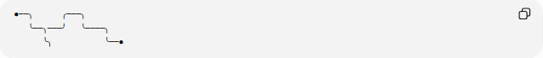
●──╮ ╭───╮
╰──╮───╯ ╰────╮
╰╮ ╰──●
The wave does not repeat in a perfectly uniform manner.

Symmetric Wavy Shapes
# Source: AI Source: Provided by: [Data Path: Persons Table -> ID Column: 1, Name_En Column: Motasem Essam] -> From: [ChatGPT] on [7/25/2026]
A Symmetric Wavy Shape remains unchanged under a particular symmetry transformation.
For reflection symmetry about the y-axis:
$$\boxed{f\left(-x\right)=f\left(x\right)}$$
For point symmetry about the origin:
$$\boxed{f\left(-x\right)=-f\left(x\right)}$$
A wavy shape can have:
- reflection symmetry
- rotational symmetry
- point symmetry
- bilateral symmetry
- radial symmetry
Important distinction
Symmetry must always be specified relative to a transformation or axis.
A shape that is not symmetric about one axis is not necessarily asymmetric under every possible symmetry transformation.

Asymmetric Wavy Shapes
# Source: AI Source: Provided by: [Data Path: Persons Table -> ID Column: 1, Name_En Column: Motasem Essam] -> From: [ChatGPT] on [7/25/2026]
An Asymmetric Wavy Shape does not remain unchanged under the specified symmetry transformation.
For a transformation T:
$$\boxed{T\left(S\right)≠S}$$
An asymmetric wave may have:
- unequal peaks
- unequal troughs
- irregular spacing
- different left and right sides
- changing amplitude
- changing frequency
Example:
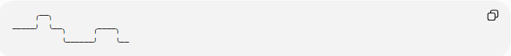
╭──╮
─────╯ ╰──╮ ╭────╮
╰──────╯ ╰──
Asymmetry and irregularity are related concepts but are not synonymous.

Mixed Wavy Shapes
# Source: AI Source: Provided by: [Data Path: Persons Table -> ID Column: 1, Name_En Column: Motasem Essam] -> From: [ChatGPT] on [7/25/2026]
A Mixed Wavy Shape combines different wavy characteristics or patterns within one shape or arrangement.
For example, different portions may have:
- different amplitudes
- different frequencies
- different curvature
- regular and irregular sections
- symmetric and asymmetric sections
A piecewise model can represent this:
$$f\left(x\right)=\left\{\begin{matrix}f_{1}\left(x\right), & x<c \\ f_{2}\left(x\right), & x≥c\end{matrix}\right.$$
For the sections to connect continuously:
$$f_{1}\left(c\right)=f_{2}\left(c\right)$$
For a smoother transition, their derivatives may also match:
$$f_{1}^{'}\left(c\right)=f_{2}^{'}\left(c\right)$$

Wave Parameters
# Source: AI Source: Provided by: [Data Path: Persons Table -> ID Column: 1, Name_En Column: Motasem Essam] -> From: [ChatGPT] on [7/25/2026]
For a regular sinusoidal wave:
$$y=Asin⁡\left(Bx+C\right)+D$$
the principal parameters are:
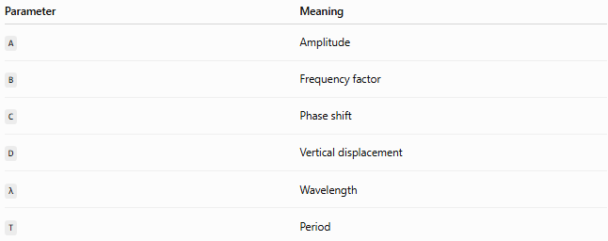
Parameter | Meaning
A | Amplitude
B | Frequency factor
C | Phase shift
D | Vertical displacement
λ | Wavelength
T | Period
The wavelength is:
$$\boxed{λ=\frac{2π}{∣B∣}}$$
For a time-based wave:
$$y=Asin⁡\left(ωt+ϕ\right)$$
the period is:
$$\boxed{T=\frac{2π}{∣ω∣}}$$

Peaks and Troughs
# Source: AI Source: Provided by: [Data Path: Persons Table -> ID Column: 1, Name_En Column: Motasem Essam] -> From: [ChatGPT] on [7/25/2026]
Many wavy curves contain alternating peaks and troughs.
- Peak → local high point
- Trough → local low point
For:
$$y=Asin⁡\left(Bx\right)$$
when A>0, the maximum value is:
$$y_{max}=A$$
and the minimum value is:
$$y_{min}=-A$$
The vertical distance from the centerline to a peak is the amplitude.

Curvature
# Source: AI Source: Provided by: [Data Path: Persons Table -> ID Column: 1, Name_En Column: Motasem Essam] -> From: [ChatGPT] on [7/25/2026]
Wavy curves usually have variable curvature.
For a graph:
$$y=f\left(x\right)$$
the curvature is:
$$\boxed{κ=\frac{∣f^{''}\left(x\right)∣}{{\left(1+{\left[f^{'}\left(x\right)\right]}^{2}\right)}^{3/2}}}$$
As the wave changes direction, its curvature changes along the curve.
This distinguishes many wavy curves from circles, whose curvature is constant:
$$κ=\frac{1}{r}$$

Arc Length
# Source: AI Source: Provided by: [Data Path: Persons Table -> ID Column: 1, Name_En Column: Motasem Essam] -> From: [ChatGPT] on [7/25/2026]
For a smooth wavy function:
$$y=f\left(x\right)$$
between x=a and x=b, the arc length is:
$$\boxed{L=\int_{a}^{b}{\sqrt{1+{\left[f^{'}\left(x\right)\right]}^{2}}} dx}$$
For a parametric wavy curve:
$$x=x\left(t\right), y=y\left(t\right)$$
the length is:
$$\boxed{L=\int_{a}^{b}{\sqrt{{\left(\frac{dx}{dt}\right)}^{2}+{\left(\frac{dy}{dt}\right)}^{2}}} dt}$$

Area of a Closed Wavy Shape
# Source: AI Source: Provided by: [Data Path: Persons Table -> ID Column: 1, Name_En Column: Motasem Essam] -> From: [ChatGPT] on [7/25/2026]
For a closed wavy curve represented parametrically by:
$$x=x\left(t\right), y=y\left(t\right)$$
the enclosed area can be calculated using:
$$\boxed{A=\frac{1}{2}\oint{(}\left.x dy-y dx\right)}$$
This is useful when the boundary is irregular or does not have a simple standard area formula.

Smooth Wavy vs Zigzag Shapes
# Source: AI Source: Provided by: [Data Path: Persons Table -> ID Column: 1, Name_En Column: Motasem Essam] -> From: [ChatGPT] on [7/25/2026]
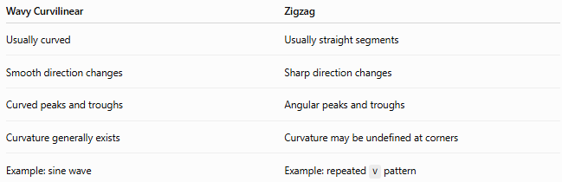
Wavy Curvilinear | Zigzag
Usually curved | Usually straight segments
Smooth direction changes | Sharp direction changes
Curved peaks and troughs | Angular peaks and troughs
Curvature generally exists | Curvature may be undefined at corners
Example: sine wave | Example: repeated V pattern
The fundamental distinction is:
$$\boxed{\text{Wavy}=\text{smooth/curved undulation}} \\ \boxed{\text{Zigzag}=\text{angular/straight-segment undulation}}$$

Wavy vs Smooth Curvilinear Shapes
# Source: AI Source: Provided by: [Data Path: Persons Table -> ID Column: 1, Name_En Column: Motasem Essam] -> From: [ChatGPT] on [7/25/2026]
These categories overlap.
Smooth describes how the curve behaves.
Wavy describes the form or pattern of the curve.
Therefore, a curve can be:
- smooth but not wavy
- wavy and smooth
- wavy but not completely smooth
For example, a circle is smooth but not normally described as wavy, while a sine wave is both wavy and smooth.

Wavy vs Freeform Curvilinear Shapes
# Source: AI Source: Provided by: [Data Path: Persons Table -> ID Column: 1, Name_En Column: Motasem Essam] -> From: [ChatGPT] on [7/25/2026]
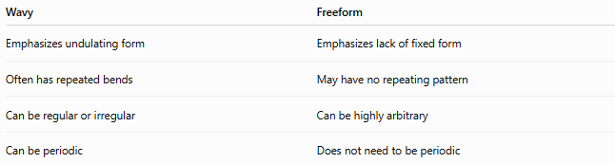
Wavy | Freeform
Emphasizes undulating form | Emphasizes lack of fixed form
Often has repeated bends | May have no repeating pattern
Can be regular or irregular | Can be highly arbitrary
Can be periodic | Does not need to be periodic
A freeform curve can therefore also be wavy.

Wavy vs Elliptical Curvilinear Shapes
# Source: AI Source: Provided by: [Data Path: Persons Table -> ID Column: 1, Name_En Column: Motasem Essam] -> From: [ChatGPT] on [7/25/2026]
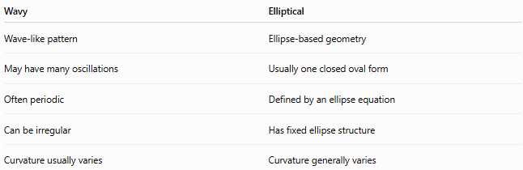
Wavy | Elliptical
Wave-like pattern | Ellipse-based geometry
May have many oscillations | Usually one closed oval form
Often periodic | Defined by an ellipse equation
Can be irregular | Has fixed ellipse structure
Curvature usually varies | Curvature generally varies
An ellipse is smooth and curvilinear, but it is not normally classified as wavy unless it has additional wave-like structure.

Classification Summary
# Source: AI Source: Provided by: [Data Path: Persons Table -> ID Column: 1, Name_En Column: Motasem Essam] -> From: [ChatGPT] on [7/25/2026]
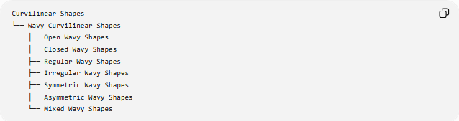
Curvilinear Shapes
└── Wavy Curvilinear Shapes
├── Open Wavy Shapes
├── Closed Wavy Shapes
├── Regular Wavy Shapes
├── Irregular Wavy Shapes
├── Symmetric Wavy Shapes
├── Asymmetric Wavy Shapes
└── Mixed Wavy Shapes
A mathematical classification can also be represented as:
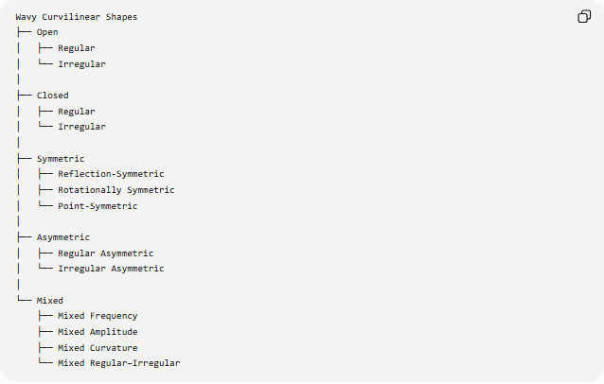
Wavy Curvilinear Shapes
├── Open
│ ├── Regular
│ └── Irregular
│
├── Closed
│ ├── Regular
│ └── Irregular
│
├── Symmetric
│ ├── Reflection-Symmetric
│ ├── Rotationally Symmetric
│ └── Point-Symmetric
│
├── Asymmetric
│ ├── Regular Asymmetric
│ └── Irregular Asymmetric
│
└── Mixed
├── Mixed Frequency
├── Mixed Amplitude
├── Mixed Curvature
└── Mixed Regular–Irregular

Key Points
# Source: AI Source: Provided by: [Data Path: Persons Table -> ID Column: 1, Name_En Column: Motasem Essam] -> From: [ChatGPT] on [7/25/2026]
- Wavy Curvilinear Shapes have wave-like curved boundaries or paths.
- Their defining characteristic is undulation, or repeated/variable changes in direction.
- They may be open or closed.
- They may be regular or irregular.
- They may be symmetric or asymmetric.
- A sinusoidal function is a common mathematical model:
$$y=Asin⁡\left(Bx+C\right)+D$$
- Wavy curves generally have variable curvature.
- Wavy and smooth are different concepts: many wavy curves are smooth.
- Wavy and zigzag shapes differ mainly in their boundary structure: curved vs angular.
- “Regular Wavy Shape” and “Mixed Wavy Shape” are useful descriptive classifications rather than universally standardized mathematical shape classes.

Conclusion
# Source: AI Source: Provided by: [Data Path: Persons Table -> ID Column: 1, Name_En Column: Motasem Essam] -> From: [ChatGPT] on [7/25/2026]
Wavy Curvilinear Shapes are curvilinear forms characterized by wave-like undulations. Their structure can range from simple periodic waves to complex irregular curves. They can also be combined with properties such as openness, closure, symmetry, asymmetry, and varying curvature.
The central idea is:
$$\boxed{\text{Wavy Curvilinear Shape}=\text{Curved Boundary with Wave-Like Undulation}}$$

